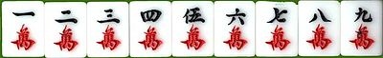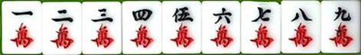
Mah Jongg and Bridge Games Day
When: Thursday June 13th, 2019, 11:15 a.m. to 4:00 p.m.
Where: Beth Jacob Synagogue, 375 Aberdeen Ave, Hamilton, ON L8P 2R7
Note: REGISTER BY WEDNESDAY JUNE 5TH/19. No registration on Games Day.
LUNCH, RAFFLES AND PRIZES
- Open to those able to play at a higher than beginner level and above
- This tournament will use the National Mah Jongg League rules and card
- We will be playing Duplicate Bridge
- Register & pay on PayPal at www.bethjacobsynagogue.ca/events/games-day/
- Or register and pay by submitting the form below by mail or email
QUESTIONS? CALL 905-522-1351 OR EMAIL: bethjacob.gamesday@gmail.com
………………………………. Tear Here …………………............................................................................................................................

Name: __________________________________________________________________________________________
Address: __________________________________________________________________________________
Email address: _____________________________________________Telephone: ____________________
I’m playing Maj I’m playing Bridge

Check one of the following:
$50 Single Ticket $100 Single Ticket + sponsorship* $100 Mitzvah Sponsorship **

*Includes recognition & $50 tax receipt ** includes recognition & $100 tax receipt but no ticket
Payment Information:
Cheque enclosed Charge my credit card I will pay on PayPal

Credit Card # ___________________________________________3 digit Security (CVS) Code ___________
Expiry Date: _______________ Name on Card: _______________________________________________
Mail your payment to: Beth Jacob Synagogue, 375 Aberdeen Ave, Hamilton ON L8P 2R7

